**HEALTH PRODUCT RECOMMENDATIONS**

**AN INTERNSHIP REPORT**

***Submitted by***

**PATEL BRINJAL JAY**



## Abstract

This project helps the users in curing its disease by giving the list of fruits and herbs that the user should consume in order to get rid of its disease. The main purpose of this project is to help the user to easily search for herbs and fruits that will be good for the health of the user depending on any health issue or disease that he/she is suffering from. This system helps the user to reduce its searching time to a great extent by allowing the user to enter its health problem and search accordingly. The admin can add fruits and herbs to the system and its information. This system also allows the user to view the selected fruit or the herb’s description which describes how the fruit or the herb will help to improve the user’s health. This system also allows the user to place order which will add the items to the user’s cart and make payment for the same. The system also includes a module in which the user can search for the hospitals depending on the name of the disease that it enters. Thus, this system helps to cure the user’s disease to a great extent. System can recommended some product to the user. If different user buy other product then this product should recommended to other active user.

List of Figures

|  |  |  |  |
| --- | --- | --- | --- |
| Sr. No. | Content |  | Pg. No. |
| 1 | Fig 1.1 | Organization chart | 2 |
| 2 | Fig 1.2 | Function use | 7 |
| 3 | Fig 1.3 | Django cycle | 8 |
| 4 | Fig 1.4 | SQLite Download and Installetion | 10 |
| 5 | Fig 1.5 | Admin panel | 22 |
| 6 | Fig 1.6 | User panel | 23 |
| 7 | Fig 1.7 | File and Folder Structure | 29 |
| 8 | Fig 1.8 | Register page | 31 |
| 9 | Fig 1.9 | OTP page | 31 |
| 10 | Fig 1.10 | Login page | 32 |
| 11 | Fig 1.11 | Home Page | 32 |
| 12 | Fig 1.12 | Profile Page | 33 |
| 13 | Fig 1.13 | Doctor page | 33 |
| 14 | Fig 1.14 | Single Doctor page | 34 |
| 15 | Fig 1.15 | Disease page | 34 |
| 16 | Fig 1.16 | Single Disease page | 35 |

List of Tables

|  |  |  |  |
| --- | --- | --- | --- |
| Sr. No. | Content |  | Pg. No. |
| 1 | Table 1.1 | App_health_disease_user | 24 |
| 2 | Table 1.2 | App_health_doctor_user | 24 |
| 3 | Table 1.3 | App_health_medicine_user | 24 |
| 4 | Table 1.4 | App_health_product_user | 25 |
| 5 | Table 1.5 | App_health_user | 25 |
| 6 | Table 1.6 | Auth_group | 25 |
| 7 | Table 1.7 | Auth_group_permissions | 25 |
| 8 | Table 1.8 | Auth_permission | 26 |
| 9 | Table 1.9 | Auth_user | 26 |

TABLE OF CONTENTS

|  |  |  |
| --- | --- | --- |
| Sr. No. | Content | Pg. No. |
| 1 | First Page | I |
| 2 | Abstract | II |
| 3 | List of Figures | III |
| 4 | List of Tables | IV |
| 5 | Table of Contents | V |
| 6 | Chapter – 1: Overview of Company  1.1 About the Company  1.2 Organization chart  1.3 Work, Product and Services of the Company | 1  1  2  2 |
| 7 | Chapter – 2: Introduction  2.1 Project Summary  2.2 Purpose  2.3 Scope  2.4 Objective  2.5 Technology  2.5.1 PYTHON  2.5.2 DJANGO  2.5.3 DBBROWSER(SQLLITE) | 3  3  4  4  4  4  5  7  9 |

|  |  |  |
| --- | --- | --- |
| 8 | Chapter – 3: Project Management  3.1 Existing System  3.2 Need for the New System  3.3 Objective of New System  3.4 Problem Definition  3.5 Core Component  3.6 Project Profile  3.7 Assumption and Constraints  3.8 Advantages and Limitations of the Proposed System | 11  11  11  11  11  12  12  12  13 |
| 9 | Chapter – 4: System Requirement  4.1 Requirement Determination and analysis  4.2 Requirement Determination  4.3 System requirements | 15  15  16  17 |
| 10 | Chapter – 5: System Analysis  5.1 Feasibility Study  5.2 Functional Requirement  5.3 Non-Functional Requirement | 19  19  19  20 |
| 11 | Chapter – 6: System Design  6.1 Target Users  6.2 Use Case Diagram  6.3 Data Dictionary | 22  22  23  25 |
| 12 | Chapter – 7: Implementation  7.1 Technologies Implementation Environment  7.2 Security Features  7.3 Coding Standards  7.4 Prototype Screen Shots | 28  28  28  29  32 |
| 13 | Chapter – 8: Testing  8.1 Testing Plan  8.2 Testing Strategy | 37  37  38 |
| 14 | Chapter – 9: Conclusion and Discussion  9.1 Problem Encountered and Possible Solutions | 39  39 |
| 15 | Chapter – 10: Limitation and Features Enhancement  10.1 Advantage  10.2 Disadvantage | 40  40  41 |
| 16 | Conclusion | 42 |
| 17 | References | 43 |

### Chapter – 1: Overview of Company

1.1 About the Company

Name: Tops Technologies

Address: 407 Dhara Arcade Opp Swaminarayan temple, Mahadev Chowk MotaVarachha Surat 394101 Gujarat

Website: www.thesunflowerlab.com

Phone no.: +91 73830 23957

About:

Tops technologies is a company offering services in the field of Software Development, Website Development, Mobile App Development, Graphic Designing, Digital Marketing, Testing & QA, Bulk SMS & Hosting Provider and IT Consultancy . In Terms Of Services, Designing and Coding. Services include customized Software Development, Website Development And Programming, Mobile App Development, Graphic Designing, Digital Marketing, Testing & QA, Bulk SMS & Hosting Provider And IT Consultancy and Maintenance. Company has a vast experience in development for Software/Web And Mobile Application. Our Processes are highly streamlined and proven to ensure fastest delivery of a high quality solution at a reasonable cost. We understand our client's need and changes over period of time. We have expertise to accommodate changes at any stage of software lifecycle.

1.2 Organization chart

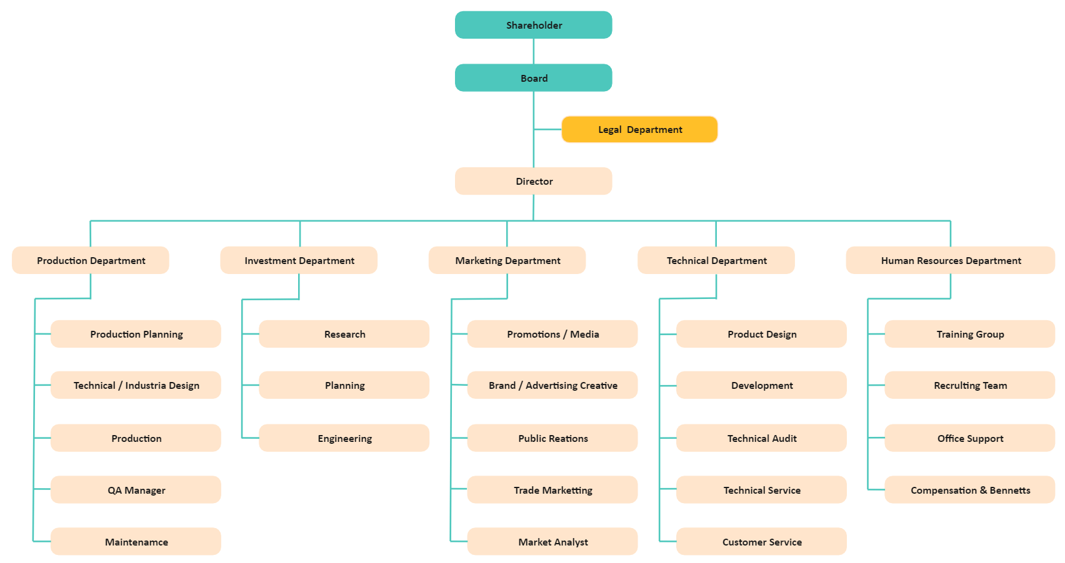

Fig 1.1 Organization chart

1.3 Work, Product and Services of the Company

We Provide A Wide Range Of Web Solutions Such As Professional Website Design And Development, Customized Software Development, Website Development And Programming, Mobile App Development, Graphic Designing, Digital Marketing, Testing & QA, Bulk SMS & Hosting Provider And IT Consultancy To A Wide Range Of Clients. We Give Our First Priority To Our Client Satisfaction. We Solve Any Query Of Our Customer With Appropriate Explainations And Also Adopt Their Ideas After Proper Discussions. We Are Available At Any Time According To Our Clients Requirement. We Do Our Best To Fulfill The Requirement Of Our Clients. We Deliver Our Product On Time And To Every Specification. We Accurately Follow The Best And Usual Web Developing Life Cycle Which Is: Planning, Analysis, Design, Implementing And Review.

**Why Choose Us?**

Tops Technologies is a company in offering services in the field of Software development, Website Development, Mobile Application Development and Customized ERP Solutions.

### Chapter – 2: Introduction

In the past decades, a considerable amount of clinical data representing patients’ health status have been collected. This has remarkably increased digital information available for patient-oriented decision making. Such digital information is often scattered across different sites, which hinders users from finding useful information for their well-being improvement. Besides, more drugs, tests, and treatment recommendations are available for medical staff daily, which triggers difficulties in deciding appropriate remedies for patients. In this context, recommender systems for medical use should be implemented to bridge these gaps and support both, patients and medical professionals, to make better healthcare-related decisions. Recommender systems have been integrated into online retailers, streaming services, and social networks to facilitate users’ item selection process. Recently, these systems have been widely applied to the healthcare domain to better support medical suggestions. Different from the precursors in the same domain, Health product recommendation offer a better personalization that increases the details of provided recommendations and improves users’ understanding of their medical condition. These systems also provide patients with a better experience, improve their health condition, and motivate them to follow a healthier lifestyle. Moreover, they also assist healthcare professionals with disease predictions/treatments. Health product recommendation should analyze patients’ health status and recommend personalized diets, exercise routines, medications, disease diagnoses, or other healthcare services. HRS’s great concern is to send the necessary information to patients at the right time while ensuring the accuracy, trustworthiness, and privacy of patient information. Moreover, these systems are expected to minimize the cost of the healthcare-related decision making process.

#### 2.1 Project Summary

In summary, HEALTH PRODUCT RECOMMENDATION is a Web Application that is helpful for recommend the product as per your disease. Its show the medicine,precoution,symptoms and product good for health.

In this modern era technology developed day by day all things we can do on the internate.This web application is one of the best example for that. Nowadays,most of hospitals have this type of websites for the online support.

#### 2.2 Purpose

The main purpose of the HEALTH PRODUCT RECOMMENDATION SYSTEM project is to provide a good and healthy product recommendation for customers. They are also book an appointment on online for emergency.this site build as per customer recommendation.In addition it is very easy to use.

#### 2.3 Scope

The objective of recommender systems is to provide recommendations based on recorded information on the users' preferences. These systems use information filtering techniques to process information and provide the user with potentially more relevant items.

#### 2.4 Objective

The main goals of health recommender systems are to retrieve trusted health information from the Internet, to analyse which is suitable for the user profile and select the best that can be recommended, to adapt their selection methods according to the knowledge domain and to learn from the best recommendations.

2.5 Technology

2.5.1 PYTHON

2.5.2 DJANGO

2.5.3 DBBROWSER(SQLLITE)

#### 2.5.1 PYTHON

# **Introduction with Python**

* Python is an interpreted, object-oriented, high-level programming language with dynamic semantics.
* Its high-level built in data structures, combined with dynamic typing and dynamic binding, make it very attractive for Rapid Application Development.
* Python supports modules and packages, which encourages program modularity and code reuse.
* The Python interpreter and the extensive standard library are available in source or binary form without charge for all major platforms, and can be freely distributed.

# **Why Python?**

* to be easy to learn and master
* Clean, clear syntax
* Very few keywords
* Highly portable
* Runs almost anywhere - high end servers and workstations, down to windows CE
* Uses machine independent byte-code
* Extensible
* Designed to be extensible using C/C++,
* allowing access to many external libraries

# **Features of Python**

* Clean syntax plus high-level data types
* Leads to fast coding (First language in many universities abroad!)
* Uses white-space to delimit blocks
* Humans generally do, so why not the language?
* Try it, you will end up liking it
* Variables do not need declaration
* Although not a type-less language

# **Python Productivity**

* Reduced development time
* code is 2-10x shorter than C, C++, Java
* Improved program maintenance
* code is extremely readable
* Less training
* language is very easy to learn

# **OOPS in Python**

* Python has been an object-oriented language since it existed. Because of this, creating and using classes and objects are downright easy.
* Overview of OOP Terminology
* **Class:** A user-defined prototype for an object that defines a set of attributes that characterize any object of the class. The attributes are data members (class variables and instance variables) and methods, accessed via dot notation.
* **Class variable:** A variable that is shared by all instances of a class. Class variables are defined within a class but outside any of the class's methods. Class variables are not used as frequently as instance variables are.
* **Data member:** A class variable or instance variable that holds data associated with a class and its objects.
* **Function overloading:** The assignment of more than one behavior to a particular function. The operation performed varies by the types of objects or arguments involved.
* **Instance variable:** A variable that is defined inside a method and belongs only to the current instance of a class.
* **Inheritance:** The transfer of the characteristics of a class to other classes that are derived from it.
* **Instance:** An individual object of a certain class. An object obj that belongs to a class Circle, for example, is an instance of the class Circle.
* **Instantiation:** The creation of an instance of a class.
* Method: A special kind of function that is defined in a class definition.
* **Object:** A unique instance of a data structure that's defined by its class. An object comprises both data members (class variables and instance variables) and methods.
* **Operator overloading:** The assignment of more than one function to a particular operator.

**Python Function**

* Python Built-in Functions.
* Python Recursion Functions.
* Python Lambda Functions.

**Python Function Declaration**

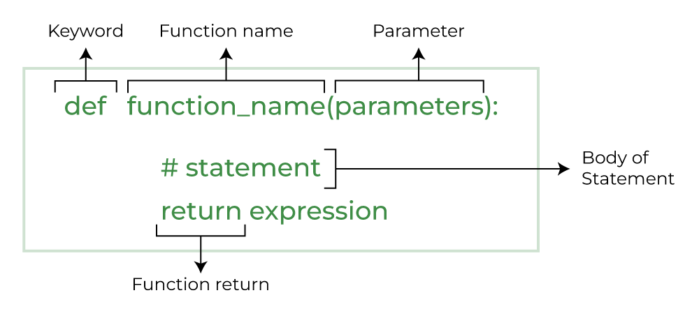

Fig 1.2 Function use

#### 2.5.2 DJANGO

* Virtual Environment
* Installation o Migration
* Settings.py
* Creating application
* Models

# **What is Django?**

* Django is a free and open source web application framework, written in Python. A web framework is a set of components that helps you to develop websites faster and easier.
* When you're building a website, you always need a similar set of components: a way to handle user authentication (signing up, signing in, signing out), a management panel for your website, forms, a way to upload files, etc.
* To understand what Django is actually for, we need to take a closer look at the servers. o The first thing is that the server needs to know that you want it to serve you a web page.
* Imagine a mailbox (port) which is monitored for incoming letters (requests). This is done by a web server.
* The web server reads the letter and then sends a response with a webpage. o But when you want to send something, you need to have some content. And Django is something that helps you create the content.

# **How It Works?**

* When a request comes to a web server, it's passed to Django which tries to figure out what is actually requested.
* It takes a web page address first and tries to figure out what to do. This part is done by Django's urlresolver (note that a website address is called a URL – Uniform Resource Locator – so the name url resolver makes sense).
* It is not very smart – it takes a list of patterns and tries to match the URL. Django checks patterns from top to bottom and if something is matched, then Django passes the request to the associated function (which is called *view*).

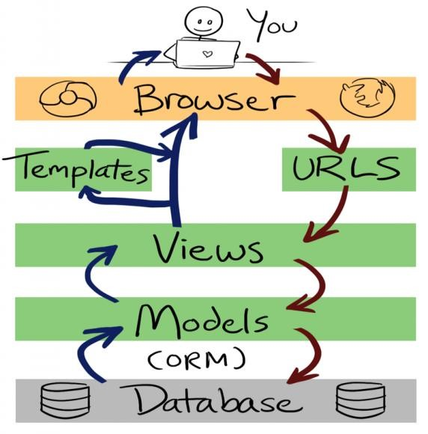

Fig 1.3 django cycle

# **Django Installation**

* **Virtual environment** 
  + - Before we install Django we will get you to install an extremely useful tool to help keep your coding environment tidy on your computer.
    - It's possible to skip this step, but it's highly recommended.
    - So, let's create a virtual environment (also called a *virtualenv*). Virtualenv will isolate your Python/Django setup on a per-project basis.
    - This means that any changes you make to one website won't affect any others you're also developing
    - All you need to do is find a directory in which you want to create the virtualenv;
    - For windows ,
    - To create a new virtualenv,you need to open the console and run C:\Python35\python –m venv myvenv.
    - It will look like this:
    - Command-line
    - C:\Users\Name\djangogirls> C:\Python35\python –m venv myvenv where C:\Python35\python is the directory in which python is installed and ‘myvenv’ is the name of your virtualenv.
    - **Working with virtualenv**
    - The command above will create a directory called ‘myvenv’ that contains our virtual environment.
    - Start your virtual environment by running :
    - Command line :
    - C:\Users\Name\djangogirls>myvenv\Scripts\activate
    - Now that you have your virtualenv started ,you can install Django.

Before we do that, we should make sure we have the latest version of pip, the software that we use to install Django.

#### 2.5.3 DBBROWSER(SQLLITE)

**What is SQLite Browser?**

DB Browser for SQLite (DB4S) is a high quality, visual, open-source tool made for creating, designing, and editing database files that are compatible with SQLite. It is for users and developers who want to create, search, design and edit [databases](https://www.edureka.co/blog/what-is-a-database/). SQLite browser uses a general spreadsheet-like interface, and there is no need to learn complicated [SQL commands](https://www.edureka.co/blog/sql-commands). It is a tool that is used by both developers and end-users, and for that reason, it has to remain as simple as possible. There are many SQLite browsers available on the internet under the name “DB Browser for SQLite”.

## **Uses of SQLite Browser**

It is a tool that lets us view the data that is stored in an SQLite Database. Depending on the format and type of data in the database it may or may not be readable by a human. This is generally used for debugging or other development tasks where the developer needs to read the data that has been stored but does not have a built-in system to access it through the program.

**Some controls and wizards are available in SQLite browsers for users to:**

* Create and compact database files
* Create, define, modify and delete tables
* Create, define and delete indexes
* Browse, edit, add, search and delete records
* Import and export records as text
* Import and export tables from/to CSV files
* Issue [SQL queries](https://www.edureka.co/blog/insert-query-sql/) and inspect the results
* Examine log of all the SQL commands issued by the application

## **How to Install SQLite browser?**

**Follow these steps to install in windows:**

* Open your favorite browser and search for SQLite and the first link will show up which is [www.sqlite.org.](http://www.sqlite.org/)
* Click on the Download link.
* In the downloads page, scroll down a little where ‘pre-compiled binaries for windows’ are present.
* Select the last option which says SQLite tools-windows32-s86 which is a zip file, download it

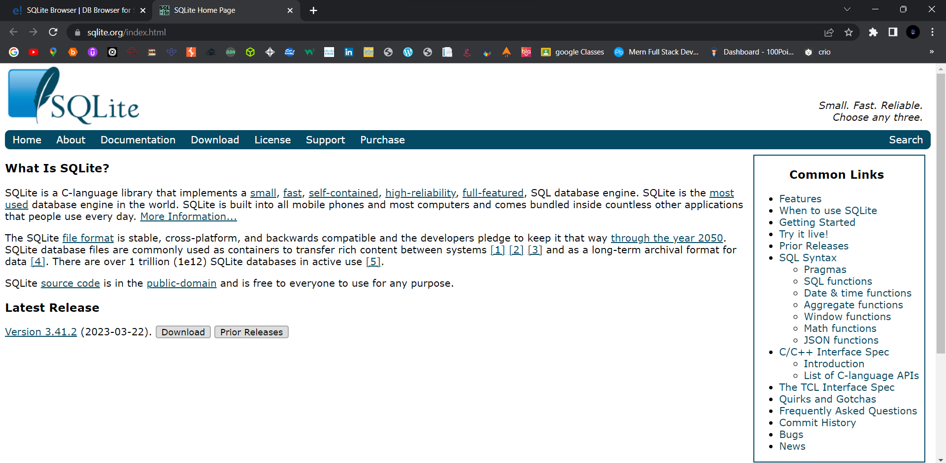

Fig 1.4 SQLite download and installetion

### Chapter – 3: Project Management

#### 3.1 Existing System

Collaborative filtering, content-based, knowledge-based, and hybrid approaches are the basic recommendation techniques that can be used in Health product recommendation system. Besides, other algorithms are also applied to generate recommendations in the healthcare domain, such as ant colony algorithm, classification, clustering, decision tree, logistic regression , natural language processing, inductive logic programming , ontologies, sparse canonical correlation, support vector machines ,semantic technologies, multi-criteria decision making, graph-based recommendations, context-aware recommendation , and matrix factorization . In this section, we present basic recommendation techniques applied in the healthcare domain.

#### 3.2 Need for the New System

There are three main aspects that need to be considered in recommender systems: usage context, users, and items . Usage context describes the environment where all elements interact with each other. Users are the end-users of recommender systems, and items are the elements that users are looking for. In the healthcare domain, additional aspects concerning the mentioned elements should be considered to generate more precise recommendations.

#### 3.3 Objective of New System

The primary objectives of Health recommendation are to:

* Streamline HR processes and tasks
* Increase productivity and efficiency
* Reduce costs associated with HR management
* Provide a user-friendly interface for HR management
* Improve data accuracy and accessibility
* Enhance employee engagement and satisfaction

#### 3.4 Problem Definition

A health product recommender is a specialization of an recommend system as defined by Ricci et al. In the context of an health product recommender, a recommendable item of interest is a piece of non-confidential, scientifically proven or at least generally accepted medical information, which in itself is not linked to an individual's medical history. However, an HRS's suggestions are driven by individualized health data such as documented in a personal health record (PHR). According to [16] this source of information is considered the user profile of an recommender system.

#### 3.5 Core Component

There are Different Types of App Component :

1. Login
2. Doctor suggetions
3. Disease
4. Product recommendations

#### 3.6 Project Profile

* Type: health product recommendations
* Modules: disease name, doctor name, product name
* Target users: all citizans
* Features: advance technology, all product recommendation as per disease
* Benefits: care your health without going any hospitals

#### 3.7 Assumption and Constraints

Assumptions:

1. The users of the system have basic computer knowledge and can operate the software with minimal training.
2. The system will be accessible through web browsers and mobile devices.
3. The system will be scalable to accommodate the growth of the organization.
4. The system will be customizable to meet the specific needs of different organizations.
5. The system will comply with data privacy regulations.
6. The implementation and integration of the health product recommendation system will not disrupt the organization's daily operations.
7. The system will be tested for performance and security before implementation.

Constraints:

1. The development team must work within the budget allocated for the project.
2. The development team must work within the timeline established for the project.
3. The system must be compatible with the existing infrastructure and technology used by the organization.
4. The organization must provide the necessary data and resources to implement and operate the system.
5. The system must be user-friendly and easy to use, requiring minimal training for users.
6. The system must be reliable and available 24/7 to ensure uninterrupted operations.
7. The organization must ensure data privacy and security to prevent unauthorized access or breaches.

#### 3.8 Advantages and Limitations of the Proposed System

Advantages of health product recommendation:

* Automates HR processes and reduces the need for manual data entry, saving time and reducing errors
* Increases efficiency and productivity by streamlining processes and reducing the need for paperwork
* Enables real-time tracking of employee data, performance metrics, sales and inventory levels, and expenses
* Provides advanced reporting and analytics capabilities for data-driven decisionmaking
* Offers a customizable and scalable solution that can be tailored to the specific needs of businesses of all sizes
* Improves compliance with various data privacy regulations and reduces legal and regulatory risks
* Facilitates better communication and collaboration among team members, managers, and HR staff

Limitations of health product recommendation:

* Initial implementation and customization costs can be high
* Requires internet connectivity for cloud-based data, which may pose a problem in areas with poor internet access
* Security risks exist for cloud-based data, and businesses must ensure adequate measures are taken to protect sensitive data
* Training and support may be required for employees to adapt to new technology and processes
* Integration with existing systems may be challenging and require additional resources and time
* The accuracy and reliability of data depend on the quality of input and system functionality, and errors can occur if data is not entered correctly or the system malfunctions.

### Chapter – 4: System Requirement

#### 4.1 Requirement Determination and analysis

Requirement determination and analysis is a crucial process in the development of the health product recommendation project. This involves gathering and analyzing the needs and expectations of the users, stakeholders, and business requirements.

The following are the requirements identified for each module of the HEALTH PRODUCT RECOMMENDATION system:

1. Sales-Sprout Module:
   * Capability to generate and manage leads
   * Sales forecasting and pipeline management
   * Automated sales processes
   * Real-time tracking of sales performance and metrics
   * Integration with the Inventory Management module

1. Inventory Management Module:
   * Real-time tracking of inventory levels and stock movements
   * Automatic inventory alerts and notifications
   * Ability to create and manage purchase orders
   * Integration with the Sales-Sprout module
   * Customizable inventory reports and dashboards

1. Expense Management Module:
   * Ability to track and manage employee expenses
   * Integration with payroll and HR systems
   * Customizable expense categories and approval workflows
   * Real-time tracking of expense reimbursements
   * Secure and compliant expense data management

1. Scheduler Module:
   * Automated scheduling and shift management
   * Availability tracking and management
   * Customizable scheduling rules and policies
   * Integration with payroll and HR systems
   * Real-time visibility of employee schedules

The requirements gathering and analysis also identified the following system requirements:

* + Cloud-based system for ease of access and scalability
  + Mobile compatibility for remote access
  + Secure data storage and management
  + Customizable user interface and access levels
  + Compliance with data privacy and security regulations.

These requirements and constraints were analyzed and incorporated into the development of the HEALTH PRODUCT RECOMMENDATION system to ensure that it meets the needs of the users and stakeholders, and also complies with regulatory requirements.

#### 4.2 Requirement Determination

Requirement determination for HEALTH PRODUCT RECOMMENDATION includes the following:

1. Sales-Sprout Module: The system should be able to manage the entire sales process, including lead management, opportunity tracking, deal closing, and sales forecasting. It should be able to generate reports on sales performance, pipeline status, and other key metrics.

1. Inventory Management Module: The system should be able to track inventory levels, monitor stock movements, and generate reports on inventory status. It should have features for managing stock levels, setting reorder points, and receiving notifications for low stock levels.

1. Expense Management Module: The system should be able to track employee expenses, including travel expenses, office expenses, and other reimbursements. It should have a user-friendly interface for employees to submit expense reports and for managers to approve or reject expenses.

1. Scheduler Module: The system should have a user-friendly interface for managing employee schedules, including shift scheduling, leave management, and attendance tracking. It should also have features for generating reports on attendance, leave balances, and other key metrics.

1. Security: The system should have robust security features, including data encryption, role-based access control, and user authentication. It should be compliant with various data privacy regulations and standards.

1. Scalability: The system should be scalable and able to handle a large number of users and transactions. It should be able to accommodate future growth and expansion.

1. Customizability: The system should be customizable to meet the specific needs and requirements of each organization. It should have features for configuring workflows, creating custom fields, and integrating with other systems.

1. Integration: The system should be able to integrate with other systems, such as payroll systems, accounting systems, and CRM systems, to streamline business processes and improve efficiency.

#### 4.3 System requirements

1. Hardware Requirements:
   * + Processor: Intel Core i5 or higher
     + RAM: 8GB or more
     + Storage: 500GB HDD or higher
     + Display: 1366 x 768 resolution or higher
     + Internet connectivity

1. Software Requirements:
   * + Operating System: Windows 10 or higher
     + Web Browser: Google Chrome, Mozilla Firefox, Safari, Microsoft Edge
     + Text Editor: Visual Studio Code or any other compatible text editor (Ref 1.1)
     + Python 3.11
     + Django 4.2.1

1. System Functional Requirements:
   * + User authentication and authorization
     + Sales-Sprout module with the ability to add, edit, and delete sales orders
     + Inventory Management module with the ability to add, edit, and delete inventory items
     + Expense Management module with the ability to add, edit, and delete expenses
     + Schedular module with the ability to schedule tasks and events
     + Dashboard with graphical representation of data
     + Reporting functionality with the ability to generate reports in PDF or CSV format

1. System Non-Functional Requirements:
   * Security: The system should have measures in place to prevent unauthorized access, data breaches, and cyber attacks.
   * Performance: The system should be able to handle a large amount of data and user traffic without significant performance issues.
   * Usability: The system should have a user-friendly interface with clear and concise instructions.
   * Accessibility: The system should be accessible to users with disabilities.
   * Scalability: The system should be able to scale up or down depending on the business needs.

### Chapter – 5: System Analysis

#### 5.1 Feasibility Study

Feasibility study is an important phase in the project management lifecycle. It determines the practicality of the project and assesses whether the project is worth pursuing. Here is a feasibility study for the health product recommendation project:

1. Technical Feasibility: The project will be implemented using Angular, a widely used web application framework. The team has sufficient technical expertise in Angular to develop the system. The necessary hardware and software resources are also available.

1. Economic Feasibility: The project will involve some upfront costs for hardware, software, and personnel. However, the benefits of the project, such as improved efficiency and productivity, are expected to outweigh the costs in the long run.

1. Operational Feasibility: The health product recommendation project is designed to streamline HR processes and improve overall efficiency. It is expected that the project will be readily accepted by end-users and will help to achieve organizational goals.

1. Schedule Feasibility: The project is expected to take approximately 6-9 months to complete. The schedule is feasible, given the availability of resources and expertise.

1. Legal Feasibility: The health product recommendation project must comply with data privacy and protection regulations, such as GDPR and CCPA. The team will ensure that the system is fully compliant with all applicable laws and regulations.

Based on the above feasibility analysis, it can be concluded that the HEALTH PRODUCT RECOMMENDATION project is feasible and worth pursuing.

#### 5.2 Functional Requirement

The functional requirements of the HEALTH PRODUCT RECOMMENDATION project include:

1. Sales-Sprout module:

* The system should allow users to create and manage sales orders.
* The system should allow users to track the status of sales orders.
* The system should allow users to generate sales reports.

2. Inventory Management module:

* The system should allow users to track inventory levels.
* The system should allow users to create and manage purchase orders.
* The system should allow users to generate inventory reports.

3. Expense Management module:

* The system should allow users to submit expense reports.
* The system should allow users to track the status of expense reports.
* The system should allow managers to approve or reject expense reports.

4. Scheduler module:

* The system should allow managers to create and manage employee schedules.
* The system should allow employees to view their schedules.
* The system should allow managers to generate schedule reports.

5. User Management module:

* The system should allow administrators to create and manage user accounts.
* The system should allow administrators to set user permissions.

6. Reporting and Analytics module:

* The system should provide advanced reporting and analytics capabilities.
* The system should allow users to generate customizable reports and dashboards.
* The system should allow users to track key performance indicators (KPIs) and metrics.

7. Compliance module:

* The system should comply with various data privacy regulations.
* The system should ensure data security and confidentiality.
* The system should provide audit trails and record-keeping features.

#### 5.3 Non-Functional Requirement

Non-functional requirements of the HEALTH PRODUCT RECOMMENDATION project could include:

1. Performance: The system must be responsive and efficient, with a fast response time for user interactions, even with large amounts of data.

1. Scalability: The system should be scalable to accommodate future growth and changes in the business requirements.

1. Security: The system must be secure to prevent unauthorized access, data theft, and data loss. It should also comply with data protection regulations and policies.

1. Usability: The system must be user-friendly and intuitive, with a simple and easy-touse interface for all users.

1. Reliability: The system must be reliable and available, with minimal downtime or disruption to operations.

1. Compatibility: The system must be compatible with different devices, platforms, and browsers to ensure that it can be used by all users.

1. Maintainability: The system must be easy to maintain and update, with a robust and flexible architecture that supports changes and modifications as required.

1. Accessibility: The system must be accessible to users with disabilities, and comply with accessibility standards and regulations.

### Chapter – 6: System Design

#### 6.1 Target Users

The target users of the HEALTH PRODUCT RECOMMENDATION project may include:

1. HR Managers: They would use the system to manage and monitor employee information, attendance, leave, performance, and other related tasks.

1. Employees: They can use the system to check their own attendance, leave balances, pay stubs, and other personal information.

1. Sales and Marketing Teams: They would use the Sales-Sprout module to manage and track sales leads, opportunities, and performance.

1. Inventory Managers: They would use the Inventory Management module to monitor and manage stock levels, orders, and purchase orders.

1. Finance Teams: They would use the Expense Management module to track and manage expenses, reimbursements, and budgets.

1. Managers and Supervisors: They would use the Schedular module to schedule employee shifts, assign tasks, and manage workloads.

Overall, the HEALTH PRODUCT RECOMMENDATION SYSTEM is designed to cater to the needs of HR departments, sales and marketing teams, inventory and finance departments, and managers who need to manage and monitor employee and business-related tasks efficiently.

Design

#### 6.2 Use Case Diagram

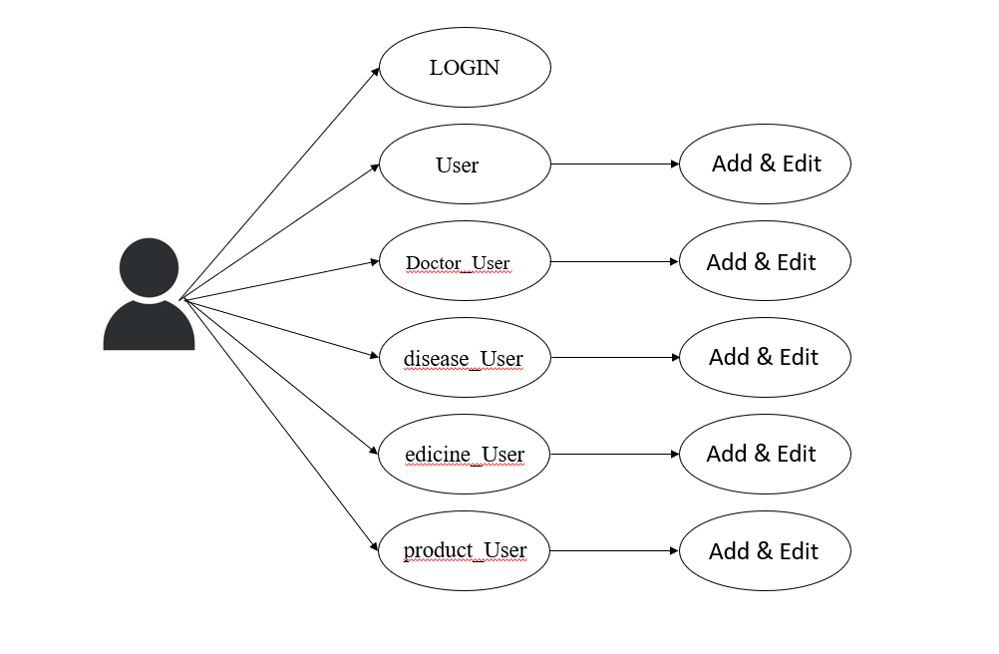

Fig 1.5 Admin panel

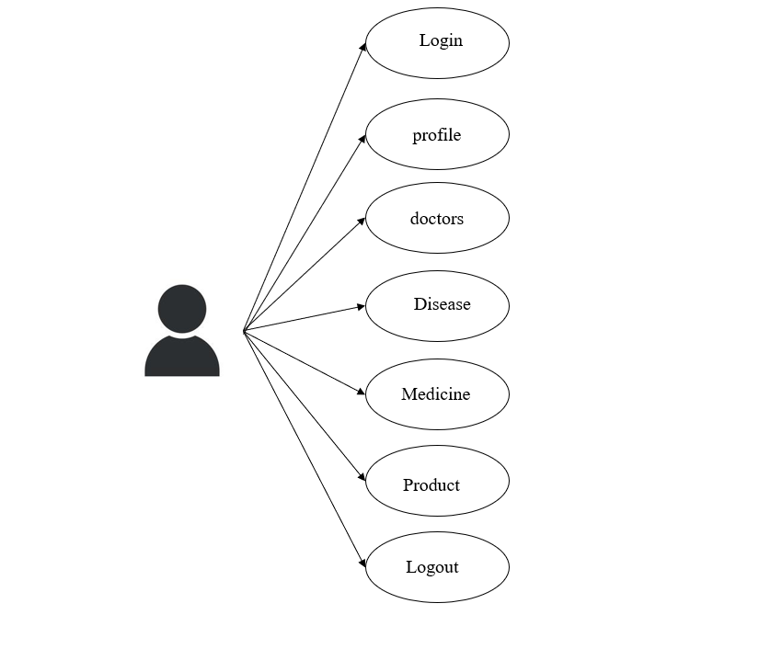

Fig 1.6 User panel

#### 6.3 Data Dictionary

|  |  |
| --- | --- |
| Field | Type |
| id | integer |
| doctor | Varchar(50) |
| diseasename | Varchar(50) |
| symptoms | Varchar(100) |
| medicinename | Varchar(50) |
| descpic | Varchar(100) |
| productname | Varchar(30) |
| precaution | Varchar(500) |

Table 1.1 app_health_disease_user

|  |  |
| --- | --- |
| Field | Type |
| Id | integer |
| doctorname | Varchar(50) |
| specializations | Varchar(50) |
| doctorpic | Varchar(100) |
| contact | Varchar(10) |
| disease | Varchar(50) |
| desc | Varchar(1500) |

Table 1.2 app_health_doctor_user

|  |  |
| --- | --- |
| Field | Type |
| Id | integer |
| productname | Varchar(50) |
| Productbenefit | Varachar(50) |
| Productdesc | Varachar(100) |
| productqty | Varachar(100) |
| productprice | Varachar(10) |

Table 1.3 app_health_medicine_user

|  |  |
| --- | --- |
| Field | Type |
| id | integer |
| productname | Varchar(30) |
| productprice | Varchar(10) |
| productbenefit | Varachar(200) |
| productdesc | Varchar(200) |
| productqty | Varchar(10) |

Table 1.4 app_health_product_user

|  |  |
| --- | --- |
| Field | Type |
| id | integer |
| fullname | Varchar(50) |
| username | Varchar(254) |
| password | Varchar(50) |
| profilepic | Varchar(100) |
| contact | Varchar(10) |

Table 1.5 app_health_user

|  |  |
| --- | --- |
| Field | Type |
| id | integer |
| name | Varchar(150) |

Table 1.6 auth_group

|  |  |
| --- | --- |
| Field | Type |
| id | integer |
| Group_id | integer |
| Permission_id | integer |

Table 1.7 auth_group_permission

|  |  |
| --- | --- |
| Field | Type |
| id | integer |
| Content_type_id | integer |
| codename | Varchar(100) |
| name | Varchar(255) |

Table 1.8 auth_permission

|  |  |
| --- | --- |
| Field | Type |
| id | Integer |
| Password | Varchar(128) |
| Last_login | datetime |
| Is_superuser | bool |
| Username | Varchar(150) |
| Last_name | Varchar(150) |
| email | Varchar(254) |
| Is_staff | bool |
| Date_joined | Datetime |
| Is_active | bool |

Table 1.9 auth_user

### Chapter – 7: Implementation

#### 7.1 Technologies Implementation Environment

Front-end Technologies:

* HTML, CSS, and JavaScript for creating web pages
* Bootstrap for responsive design and layout
* Angular Material for UI components

Back-end Technologies:

* python
* Django
* DBBrowser(SQLLite)
* MYSQL

Development Tools:

* Visual Studio IDE for coding and debugging
* GitLab for version control and source code management
* Postman for API testing

#### 7.2 Security Features

1. Role-based access control: User roles can be defined and assigned varying levels of access to different modules and features within the system. This ensures that users can only view and modify data that is relevant to their job functions.

1. Authentication: Require users to enter valid login credentials to access the system, such as a username and password. Use strong password policies, such as minimum length and complexity requirements, to ensure that user accounts are secure.

1. Authorization: Implement role-based access control to restrict access to sensitive features and data. Users should only be able to access the features and data that they are authorized to view or modify based on their roles and permissions.

1. Encryption: Encrypt sensitive data, such as passwords, credit card information, and personal identification numbers (PINs), to protect them from unauthorized access. Use industry-standard encryption algorithms and keys to ensure that the data cannot be easily decrypted.

1. Input validation: Validate all input data to prevent injection attacks, such as SQL injection and cross-site scripting (XSS). Use server-side validation to check for invalid characters and data types to prevent malicious code from executing.

1. Error handling: Implement error handling to prevent attackers from exploiting system vulnerabilities by intercepting error messages. Provide clear and concise error messages that do not reveal sensitive system information.

1. Session management: Manage user sessions securely to prevent session hijacking and replay attacks. Implement session timeouts and use secure session IDs to ensure that sessions are not hijacked.

1. Audit logging: Record all system activities, such as login attempts, data modifications, and system events, to track user actions and detect suspicious behavior. Monitor logs regularly to identify potential security threats.

1. Regular updates and patches: Keep the system up-to-date with the latest security patches and updates to prevent known vulnerabilities from being exploited.

By implementing these security features, the HEALTH PRODUCT RECOMMENDATION project can ensure that sensitive data is protected and user access is secure.

#### 7.3 Coding Standards

1. File and Folder Structure: Use a consistent and logical file and folder structure that makes it easy to navigate and find files. Use naming conventions that are descriptive and easy to understand.

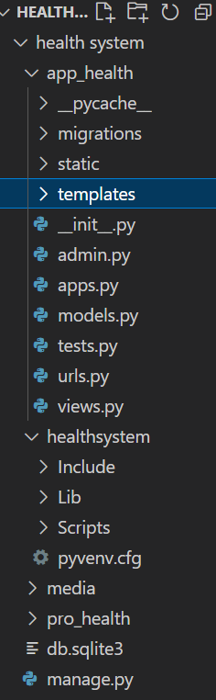

Fig 1.7 File and Folder Structure

1. Indentation and Spacing: Use consistent indentation and spacing throughout the project. Use two spaces for indentation and avoid using tabs. Use whitespace to make the code more readable and easier to understand.

1. Comments: Use comments to explain the code and make it easier for other developers to understand what the code is doing. Use clear and concise comments that explain what the code is doing, but avoid over-commenting.

1. Naming Conventions: Use descriptive and meaningful names for variables, functions, and classes. Use camelCase for naming variables and functions, and PascalCase for naming classes.

1. Error Handling: Implement proper error handling to prevent unexpected errors from occurring. Use try-catch blocks to catch errors and handle them appropriately.

1. Code Reusability: Write code that is reusable and modular. Use functions and components to break down complex code into smaller, more manageable pieces.

1. Code Formatting: Use a consistent code formatting style throughout the project. Use a tool like Prettier to automatically format the code and ensure consistency.

1. Testing: Write tests to ensure that the code is working as expected. Use a testing framework like Jasmine or Jest to write and run tests.

1. Version Control: Use a version control system like Git to manage changes to the code. Use descriptive commit messages to explain the changes that were made.

By following these coding standards, the SF-HRMS project can have a clean, consistent, and maintainable codebase that is easy to understand and modify.

#### 7.4 Prototype Screen Shots

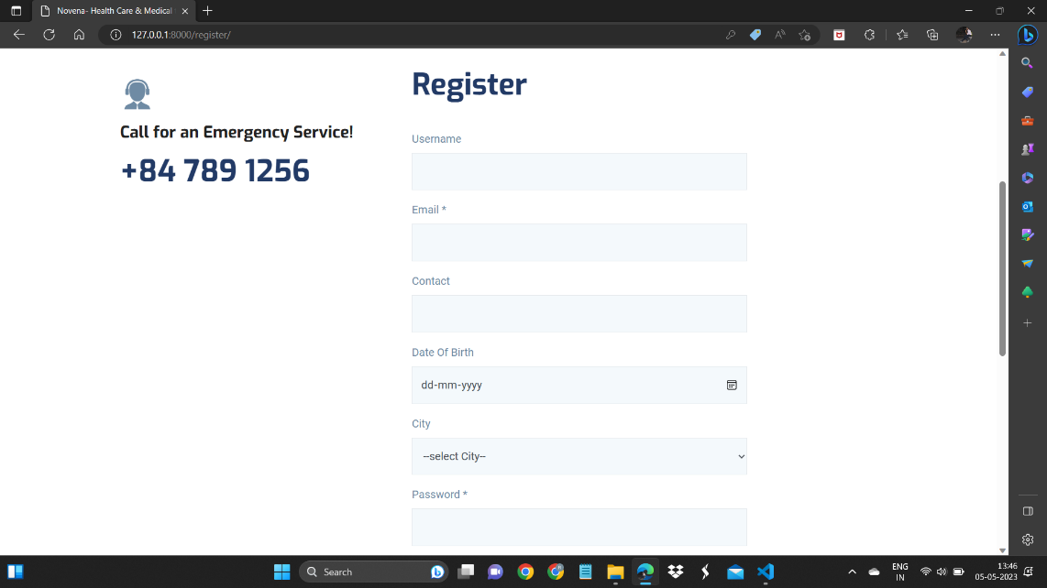

Fig 1.8 Register page

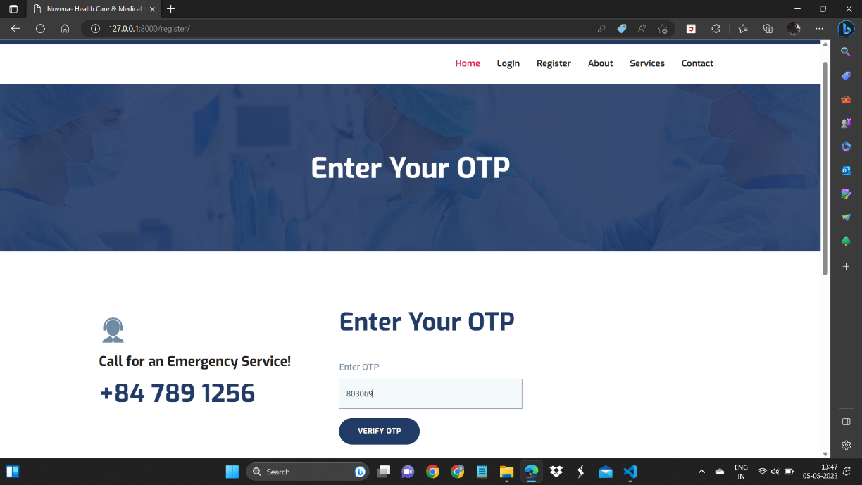

Fig 1.9 OTP page

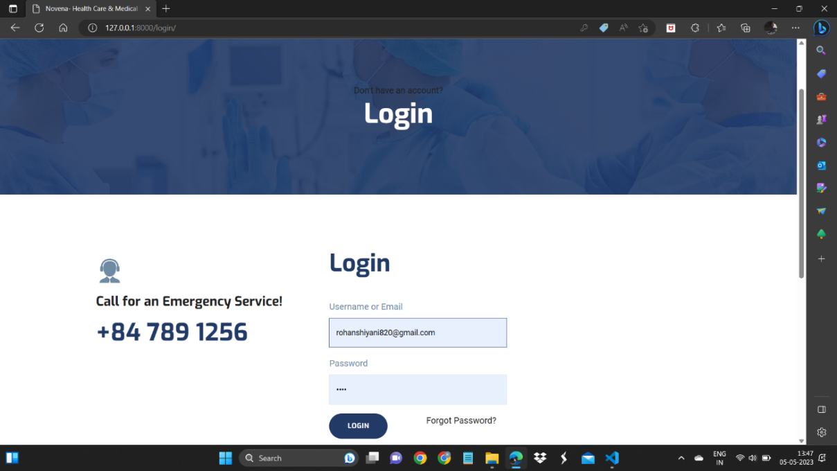

Fig 1.10 LogIn page

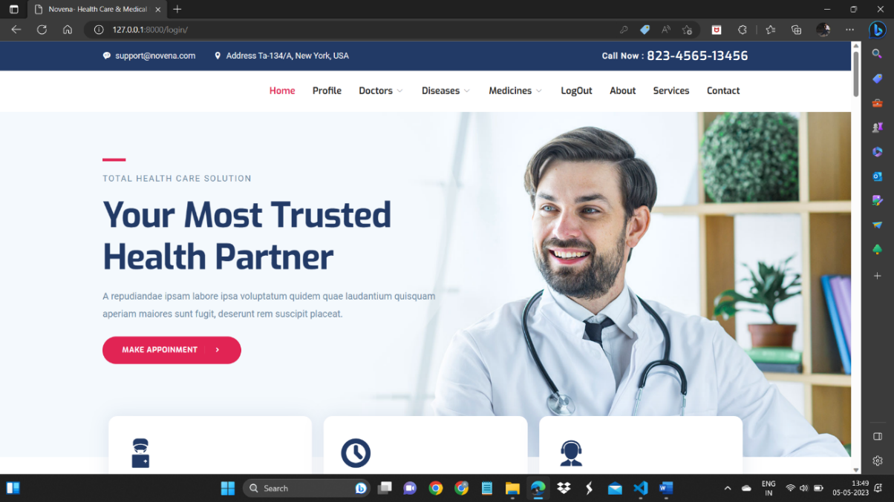

Fig 1.11 Home page

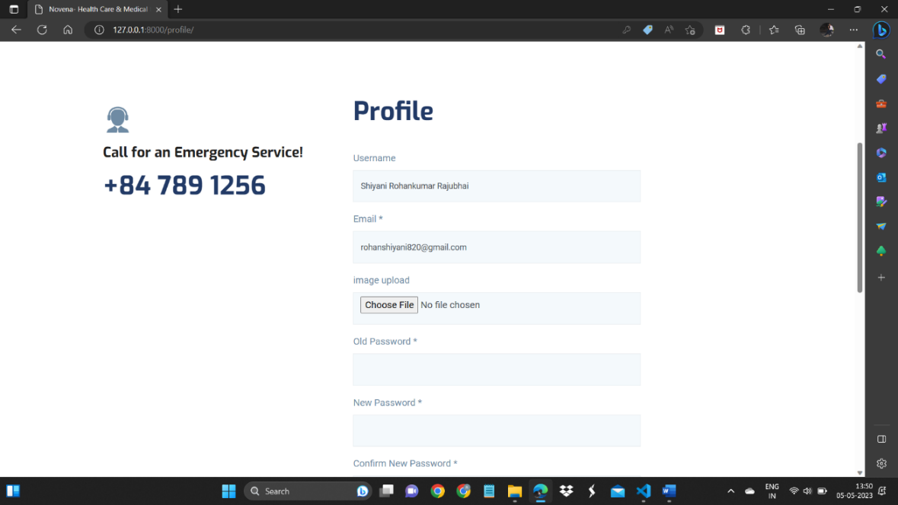

Fig 1.12 Profile page

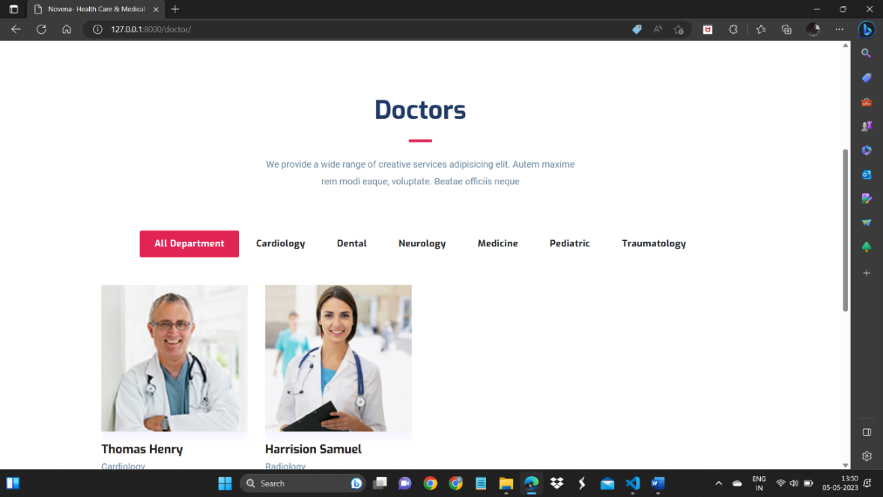

Fig 1.13 Doctor page

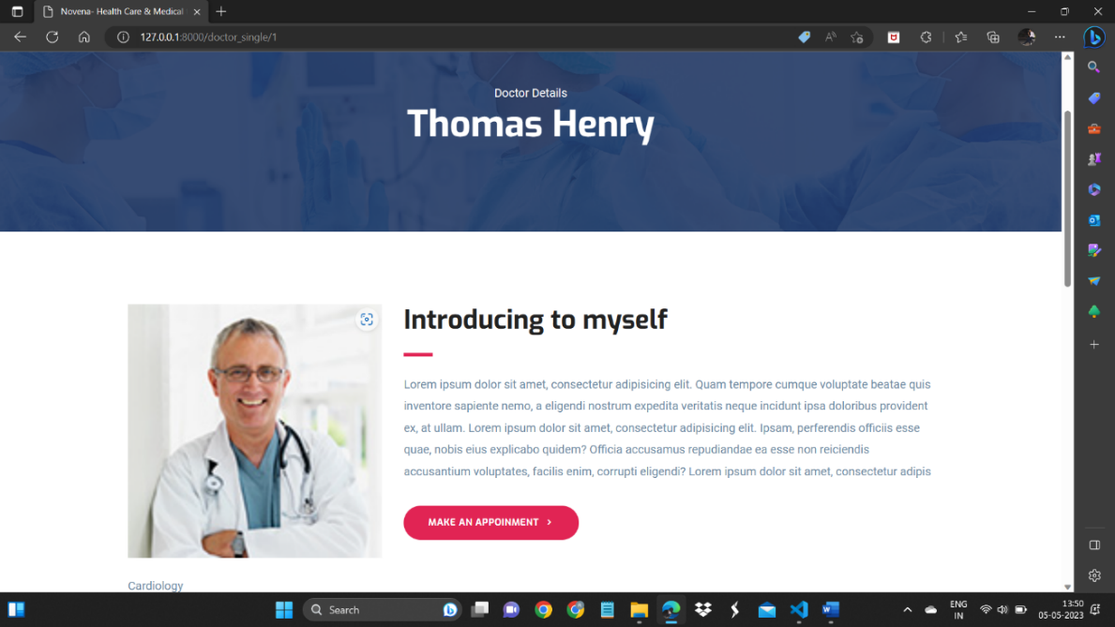

Fig 1.14 Single doctor page

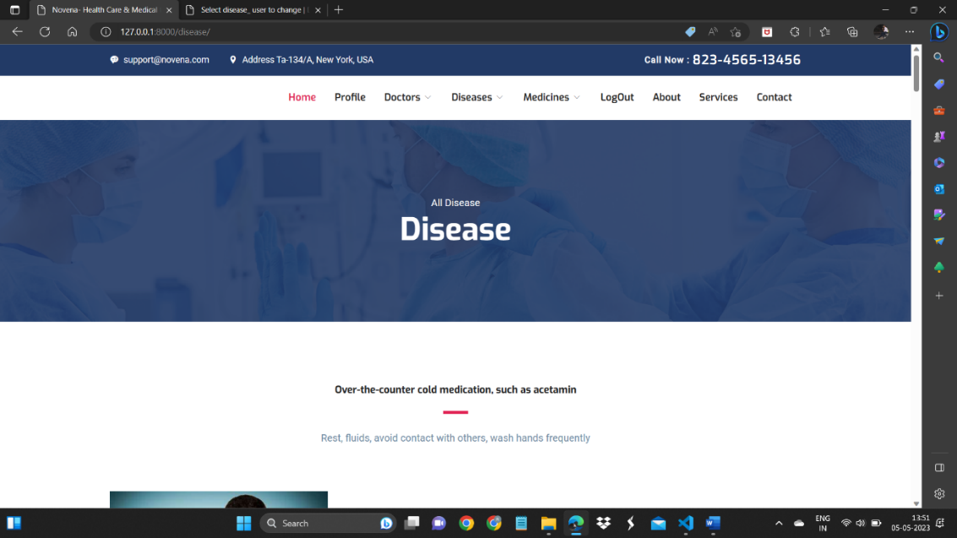

Fig 1.15 Disease page

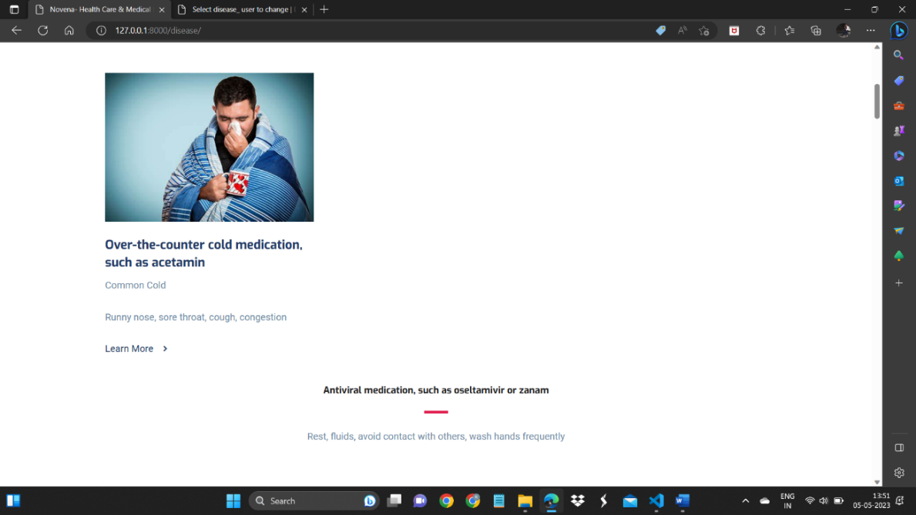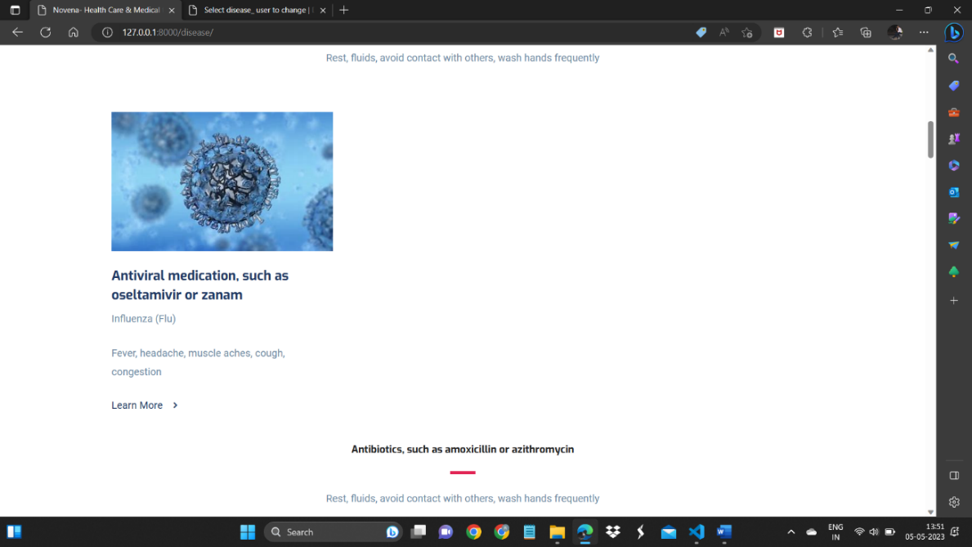

Fig 1.16 Single Disease page

### **Chapter – 8: Testing**

#### 8.1 Testing Plan

A testing plan for HEALTH PRODUCT RECOMMENDATION should include the following steps:

1. Unit Testing: The individual modules of the system should be tested for their functionality and accuracy. This includes testing the Sales-Sprout, Inventory Management, expense management and schedular module to ensure that each module performs as intended.

1. Integration Testing: After the individual modules have been tested, they should be integrated and tested as a whole to ensure that they work together properly. This includes testing the integration of Sales-Sprout, Inventory Management, expense management and schedular module.

1. User Acceptance Testing: Once the system has been developed and integrated, it should be tested by end-users to ensure that it meets their requirements and expectations. This includes testing the Sales-Sprout, Inventory Management, expense management and schedular module from a user perspective.

1. Performance Testing: The system should be tested to ensure that it performs well under expected workloads. This includes testing the Sales-Sprout, Inventory Management, expense management and schedular module under high loads to ensure that the system performs as expected.

1. Security Testing: The system should be tested to ensure that it is secure and that user data is protected. This includes testing the Sales-Sprout, Inventory Management, expense management and schedular module for security vulnerabilities and ensuring that appropriate security measures are in place.

1. Regression Testing: After each change to the system, it should be tested to ensure that no other parts of the system have been affected. This includes testing the SalesSprout, Inventory Management, expense management and schedular module after each update or change to the system.

1. User Training Testing: The system should be tested to ensure that it is easy to use and understand for end-users. This includes testing the Sales-Sprout, Inventory Management, expense management and schedular module with end-users to ensure that they can use the system effectively.

By following these testing steps, the health product recommendation system can be thoroughly tested and ensured to be functioning properly.

#### 8.2 Testing Strategy

The testing strategy for the health product recommendation project can include the following steps:

1. Test Planning: The testing team should prepare the test plan, which outlines the testing approach, scope, objectives, and timelines.

1. Test Design: The testing team should design test cases that cover all the functional and non-functional requirements of the system.

1. Test Execution: The testing team should execute the test cases to validate that the system works as expected.

1. Defect Reporting: The testing team should report any defects found during testing to the development team so that they can be fixed.

1. Retesting: The testing team should retest the system after the defects have been fixed to ensure that the fixes are successful.

1. Acceptance Testing: Once the testing team has completed their testing, the system should be subjected to user acceptance testing to ensure that it meets the requirements of the end-users.

1. Regression Testing: Any time changes are made to the system, regression testing should be performed to ensure that the changes have not introduced new defects or broken existing functionality.

The testing strategy should aim to ensure that the health product recommendation system is fully functional, reliable, and user-friendly. The testing team should use a combination of manual and automated testing methods to ensure that all aspects of the system are thoroughly tested. Additionally, the testing team should work closely with the development team throughout the development lifecycle to ensure that any issues are identified and addressed as early as possible.

### **Chapter – 9: Conclusion and Discussion**

#### 9.1 Problem Encountered and Possible Solutions

During the development and implementation of the health product recommendation project, several problems may be encountered. Some possible problems and solutions are:

1. Integration issues: One of the main challenges of implementing health product recommendation is integrating the different modules, including adding product, Inventory Management, doctor management. To solve this problem, proper planning and coordination should be done between the development team and stakeholders to ensure that all modules work seamlessly.

1. Data migration issues: Migrating data from the earlier health product recommendation system, which is based on data, to health product recommendaton may pose a challenge. The solution to this problem is to conduct a thorough data analysis and mapping before migration. Also, data cleansing and validation should be done to ensure data accuracy.

1. User adoption issues: If the health product recommendation system is not user-friendly, employees may resist using it. To encourage user adoption, proper training and orientation should be conducted. Additionally, user feedback should be considered during the development and implementation phases.

1. Technical issues: Technical problems such as system crashes, software bugs, and network issues can hinder the smooth running of the health product recommendation system. To mitigate these issues, proper testing and quality assurance should be done before the system goes live. Also, regular maintenance and updates should be done to prevent technical problems.

1. Security issues: With sensitive employee and company data being stored in the system, security is a top concern. Measures such as data encryption, access control, and regular security audits should be implemented to prevent unauthorized access and data breaches.

Overall, by addressing these potential problems and implementing solutions, health product recommendation can be successfully developed and implemented, offering several advantages over the earlier health product recommendation system based on past data.

Chapter – 10: Limitation and Features Enhancement

### **Chapter – 10: Limitation and Features Enhancement**

#### 10.1 Advantage

The advantages of the health product recommendation system over the earlier HPR system based on past data are:

1. Increased Efficiency: The health product recommendation system is designed to automate various HR processes such as disease, product, doctors, and medicines. This automation saves time and increases efficiency compared to going hospital.

1. Improved Accuracy: The health product recommendation system eliminates the need for manual data entry and reduces the risk of errors. The data is entered and processed automatically, leading to improved accuracy.

1. Real-time Reporting: The health product recommendation system provides real-time reporting and analytics, which helps management make informed decisions quickly. This feature is not available in the earlier health product recommendation system.

1. Better Security: The health product recoomendation system is designed with better security features such as data encryption, user access controls, and backup systems. This improves the overall security of the system compared to the earlier health product recommendation system based on past data.

1. Scalability: The health product recommendation system is scalable and can easily accommodate the growing needs of an organization. This is not possible with the earlier health product recommendation system based on core excel, which has limitations on its scalability.

1. Automation: The health product recommendation system automates many of the HR processes, such as leave management, attendance tracking, and payroll management, which eliminates the need for manual data entry and reduces the likelihood of errors.

1. Integration: The health product recommendation system includes Sales-Sprout, Inventory Management, expense management, and a schedular module, all of which are integrated into one system, making it easier to manage all aspects of the business.

1. Data management: The health product recommendation system provides a centralized location for all employee data, including personal information, performance data, and training records.

This makes it easier to access and manage employee information.

Overall, the HEALTH PRODUCT RECOMMENDATION system is a more efficient and effective way to manage HR processes, saving time, reducing errors, and providing better data and reporting capabilities.

#### 10.2 Disadvantage

Some potential disadvantages of a modern health product recommendation system over an earlier health product recommendation system based on past data include:

1. Complexity: Modern health product recommendation systems can be more complex than past data, requiring more training for users and potential technical issues that may arise.
2. Dependence on technology: Modern health product recommendation systems are dependent on technology and require continuous updates, maintenance, and support, which may not be necessary with an past data system.

Overall, the advantages and disadvantages of a modern H system versus an Excel-based system will depend on the specific needs and requirements of the business.

### Conclusion

In conclusion, health product recommendation is a modern and efficient system that integrates various modules such as Product recommendation, data, doctors to streamline HR processes in an organization. The system aims to improve productivity, reduce errors, and enhance data accuracy, leading to better decision-making. With the use of python,Django, the system will have a user-friendly interface, making it easy to navigate and use for all employees.

The project has been developed by considering various requirements, assumptions, and constraints, and a feasibility study has been conducted to ensure its viability. The system has both functional and non-functional requirements, and a testing plan and strategy have been developed to ensure its quality and reliability.

Overall, health product recommendation will provide significant benefits to the organization, including improved efficiency, reduced costs, and enhanced data accuracy. The system's modular approach also allows for future expansion and customization, ensuring its longevity and relevance in the organization's changing needs.

### References

1. **Virtual Studio Code:** <https://code.visualstudio.com/>
2. **Django:** <https://www.djangoproject.com/>
3. **DB Browser(SQLlite):** https://sqlitebrowser.org/dl/
4. **W3Schools:** <https://www.w3schools.com/django/>
5. **Payment :** https://razorpay.com/